**MUHAMMAD HARITH BIN ZAINUDIN**

**192171**

**Lab Practice 4**

1. *Display the employee id, their first names and last names joined together, the length of the employee last name, and the numeric position of the letter a in the employee last name for those whose last names end with the letter n.*

**ANSWERS :**

select employee_id, first_name || ' ' || last_name AS full_name, length(last_name), instr(last_name,'a')

from employees

where last_name like '%n'

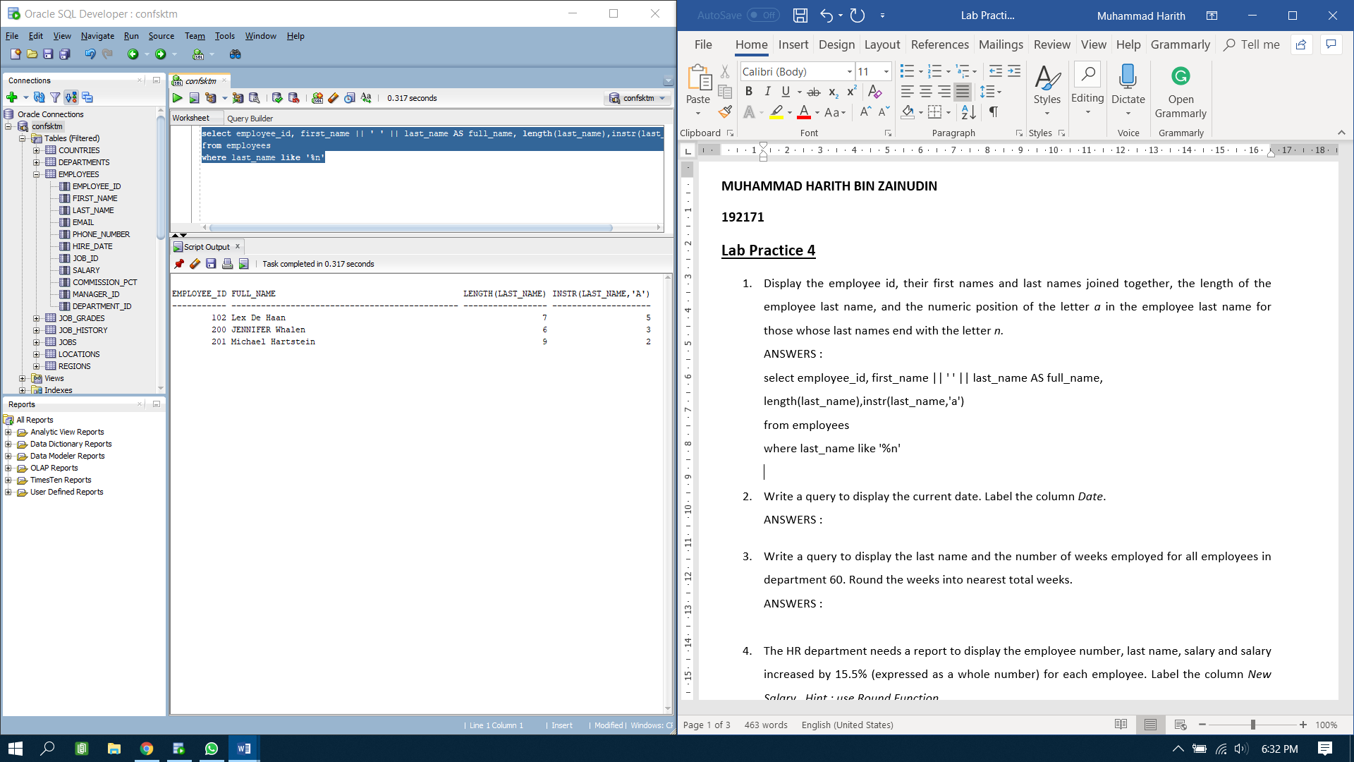

1. *Write a query to display the current date. Label the column Date.*

**ANSWERS :**

select current_date as Dates

from employees

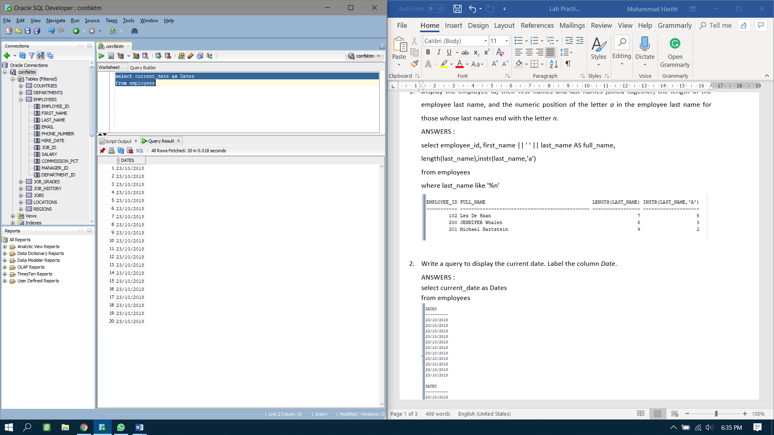

1. *Write a query to display the last name and the number of weeks employed for all employees in department 60. Round the weeks into nearest total weeks.*

**ANSWERS :**

select last_name, round((current_date-hire_date)/7)

from employees

where department_id = 60

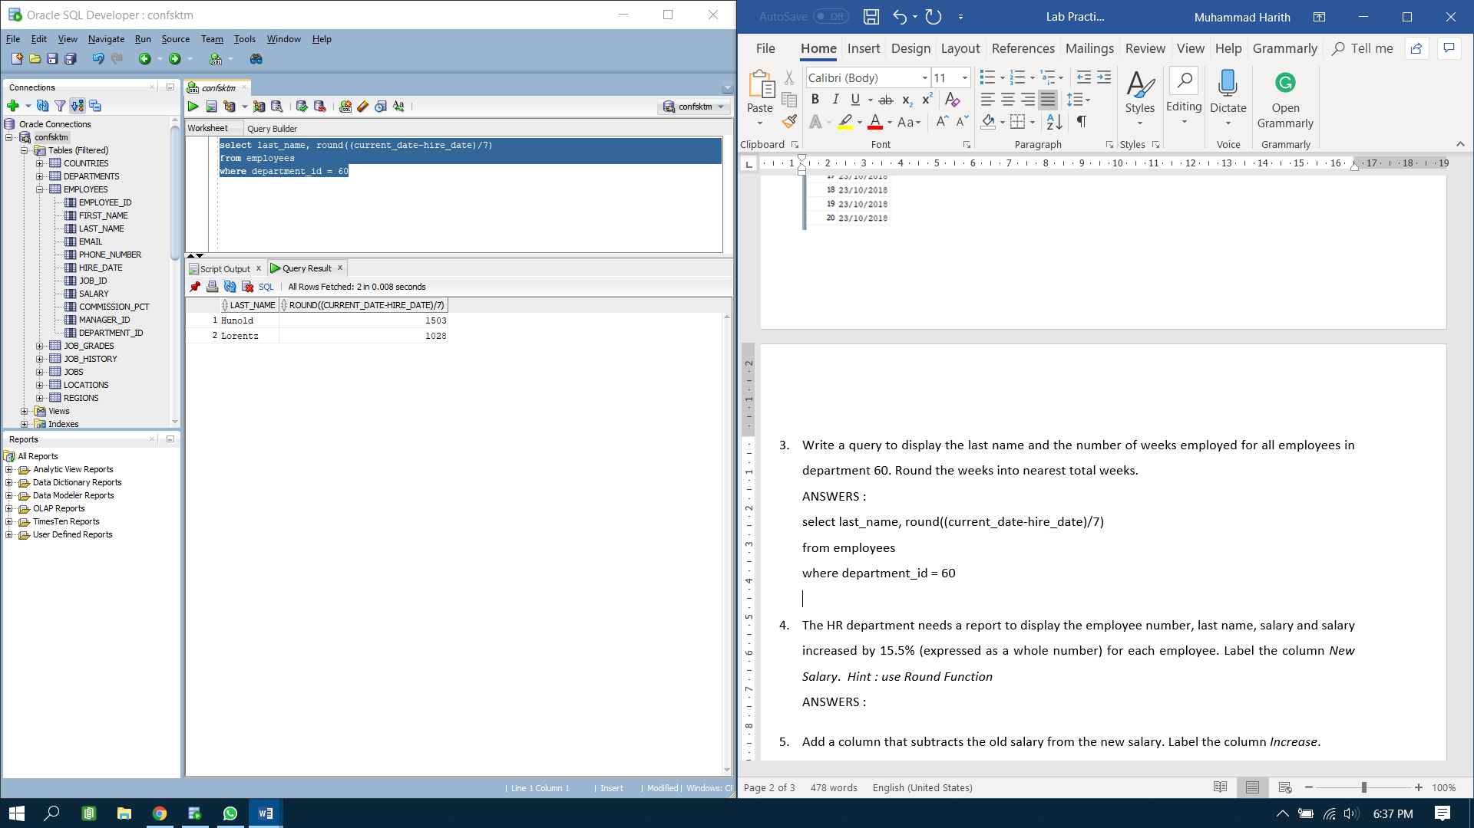

1. *The HR department needs a report to display the employee number, last name, salary and salary increased by 15.5% (expressed as a whole number) for each employee. Label the column New Salary. Hint : use Round Function*

**ANSWERS :**

select employee_id, last_name, salary, round (salary + (salary*(15.5/100))) as new_salary

from employees

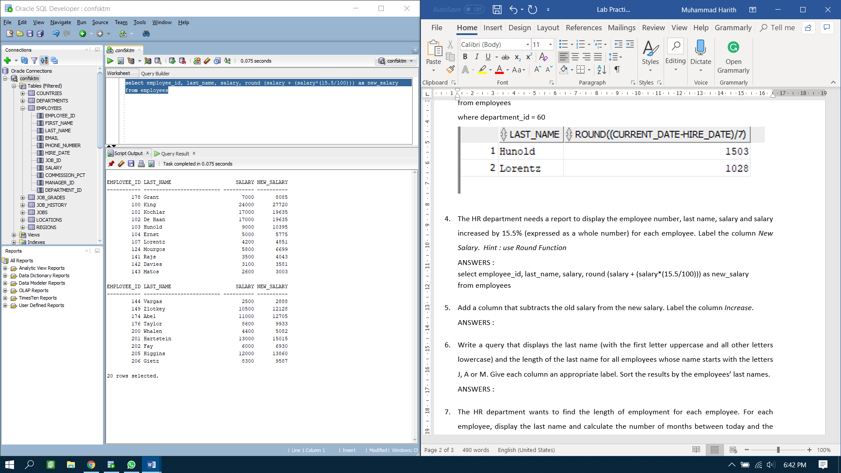

1. *Add a column that subtracts the old salary from the new salary. Label the column Increase.*

**ANSWERS :**

select round ((salary*1.155)-salary) as increase

from employees

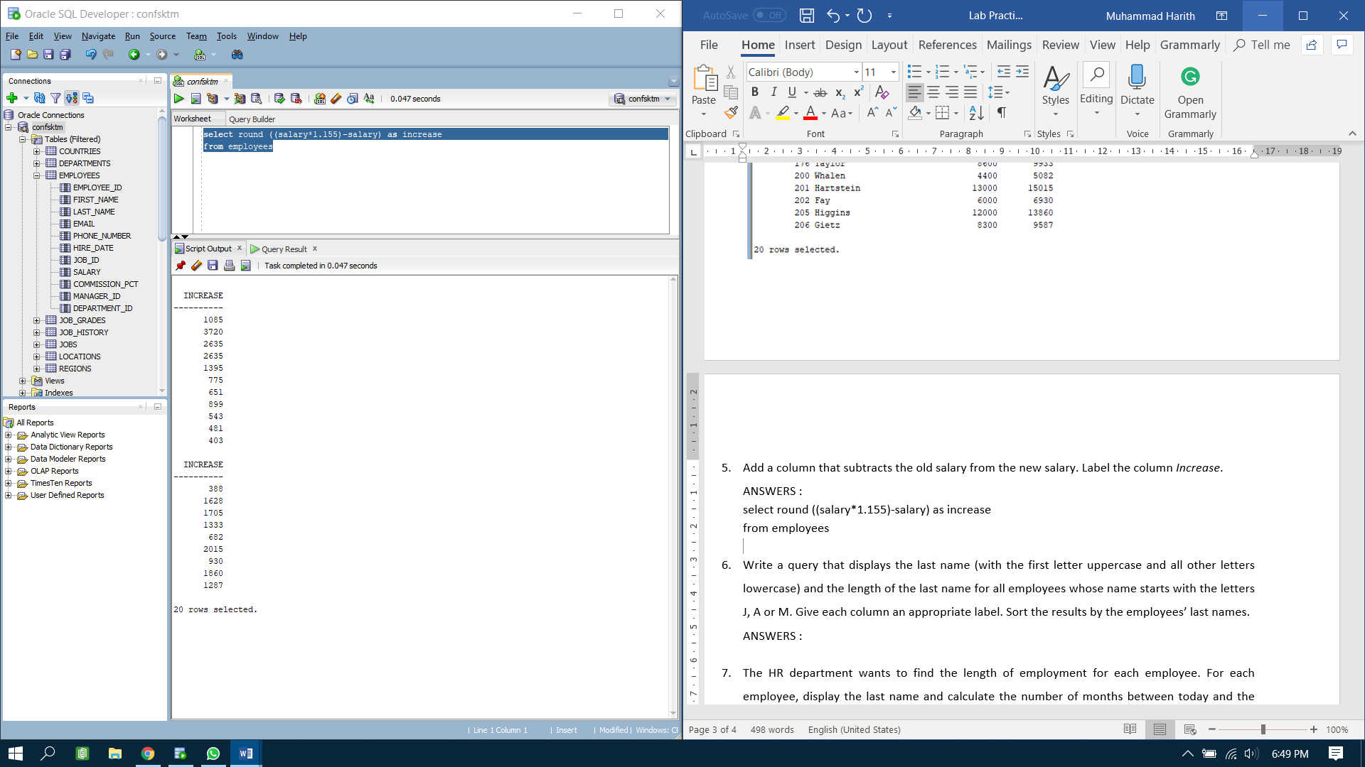

1. *Write a query that displays the last name (with the first letter uppercase and all other letters lowercase) and the length of the last name for all employees whose name starts with the letters J, A or M. Give each column an appropriate label. Sort the results by the employees’ last names.*

**ANSWERS :**

select initcap(last_name) as last_name, length(last_name) as last_name_length

from employees

where last_name like 'M%' or last_name like 'A%' or last_name like 'J%'

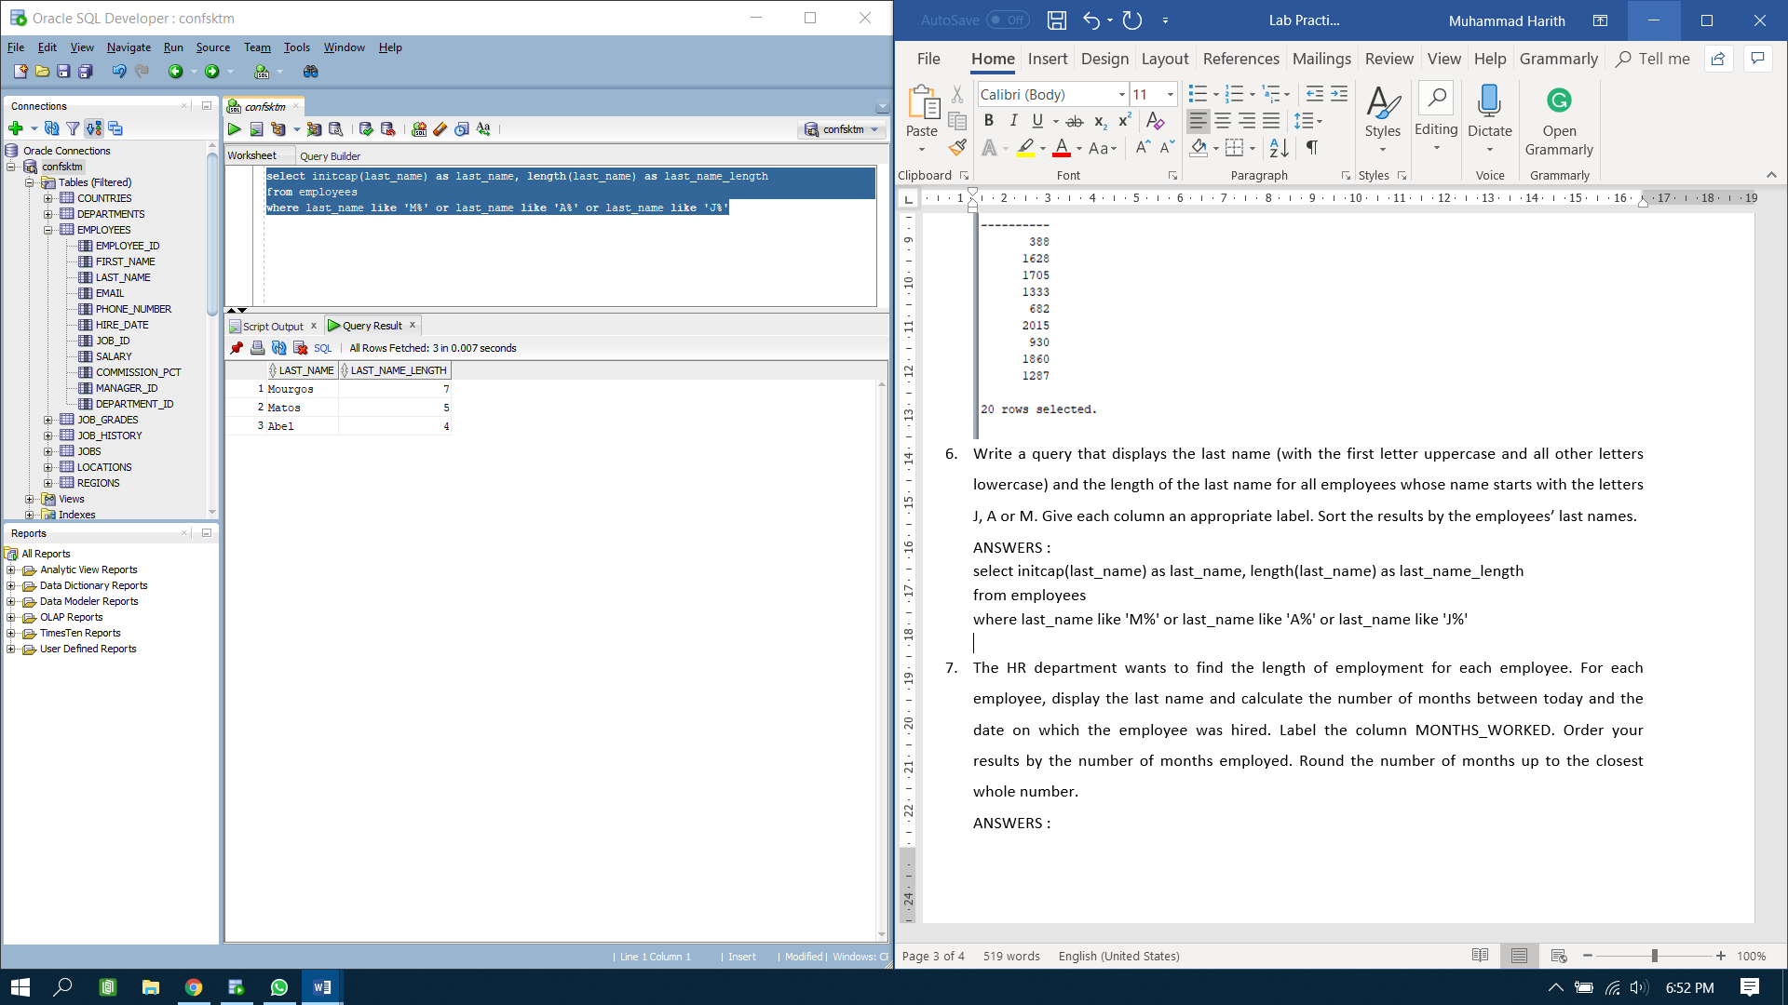

1. *The HR department wants to find the length of employment for each employee. For each employee, display the last name and calculate the number of months between today and the date on which the employee was hired. Label the column MONTHS_WORKED. Order your results by the number of months employed. Round the number of months up to the closest whole number.*

**ANSWERS :**

select last_name, round ((current_date-hire_date)/30) as months_worked

from employees

order by months_worked asc

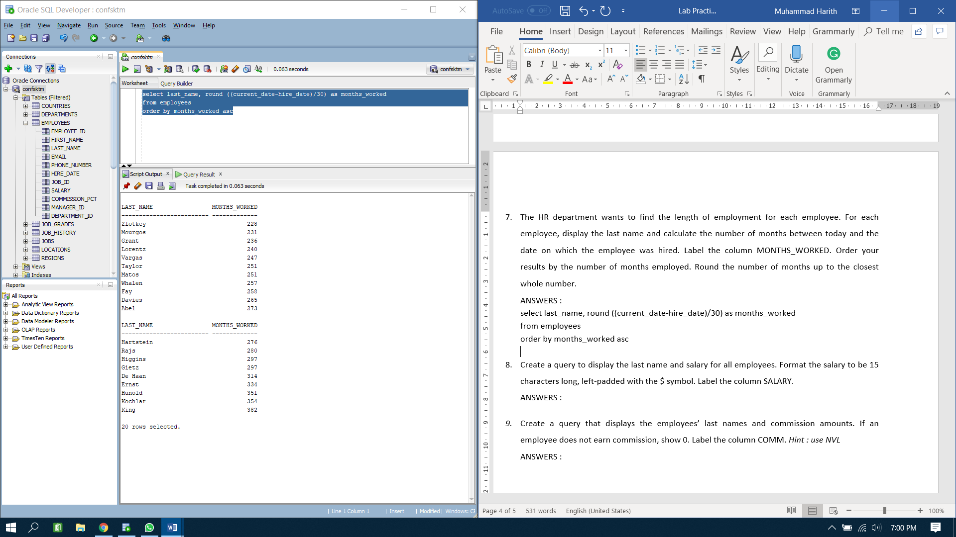

1. *Create a query to display the last name and salary for all employees. Format the salary to be 15 characters long, left-padded with the $ symbol. Label the column SALARY.*

**ANSWERS :**

select last_name, substr(salary,0,15) || '$' as salary

from employees

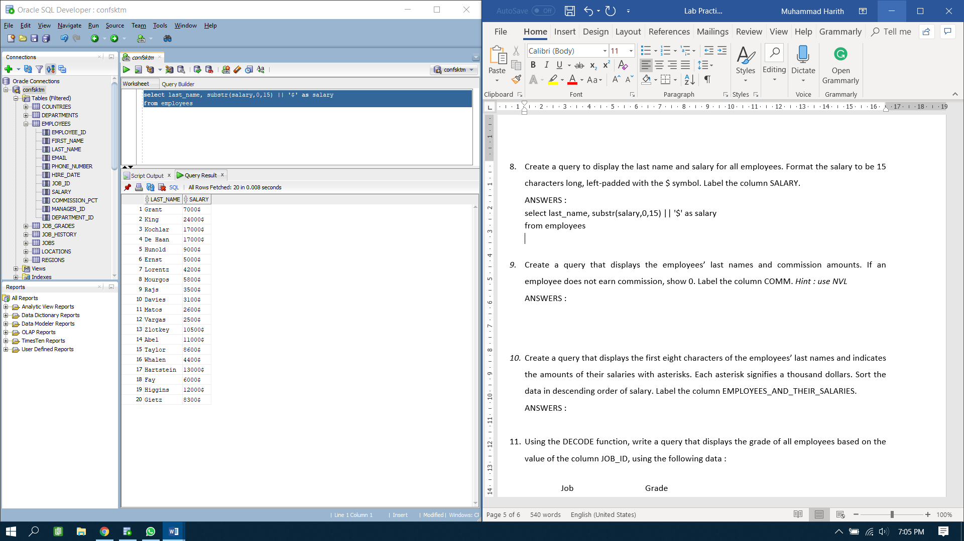

1. *Create a query that displays the employees’ last names and commission amounts. If an employee does not earn commission, show 0. Label the column COMM. Hint : use NVL*

**ANSWERS :**

select last_name, nvl(commission_pct,0) as comm

from employees

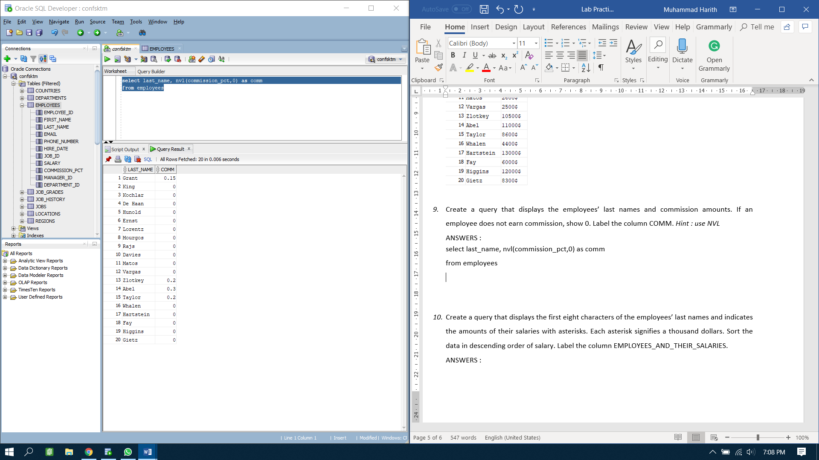

1. *Create a query that displays the first eight characters of the employees’ last names and indicates the amounts of their salaries with asterisks. Each asterisk signifies a thousand dollars. Sort the data in descending order of salary. Label the column EMPLOYEES_AND_THEIR_SALARIES.*

**ANSWERS :**

select substr(last_name,0,8) || ' ' || LPAD('*', salary/1000, '*') as employee_and_their_salaries

from employees

order by salary asc

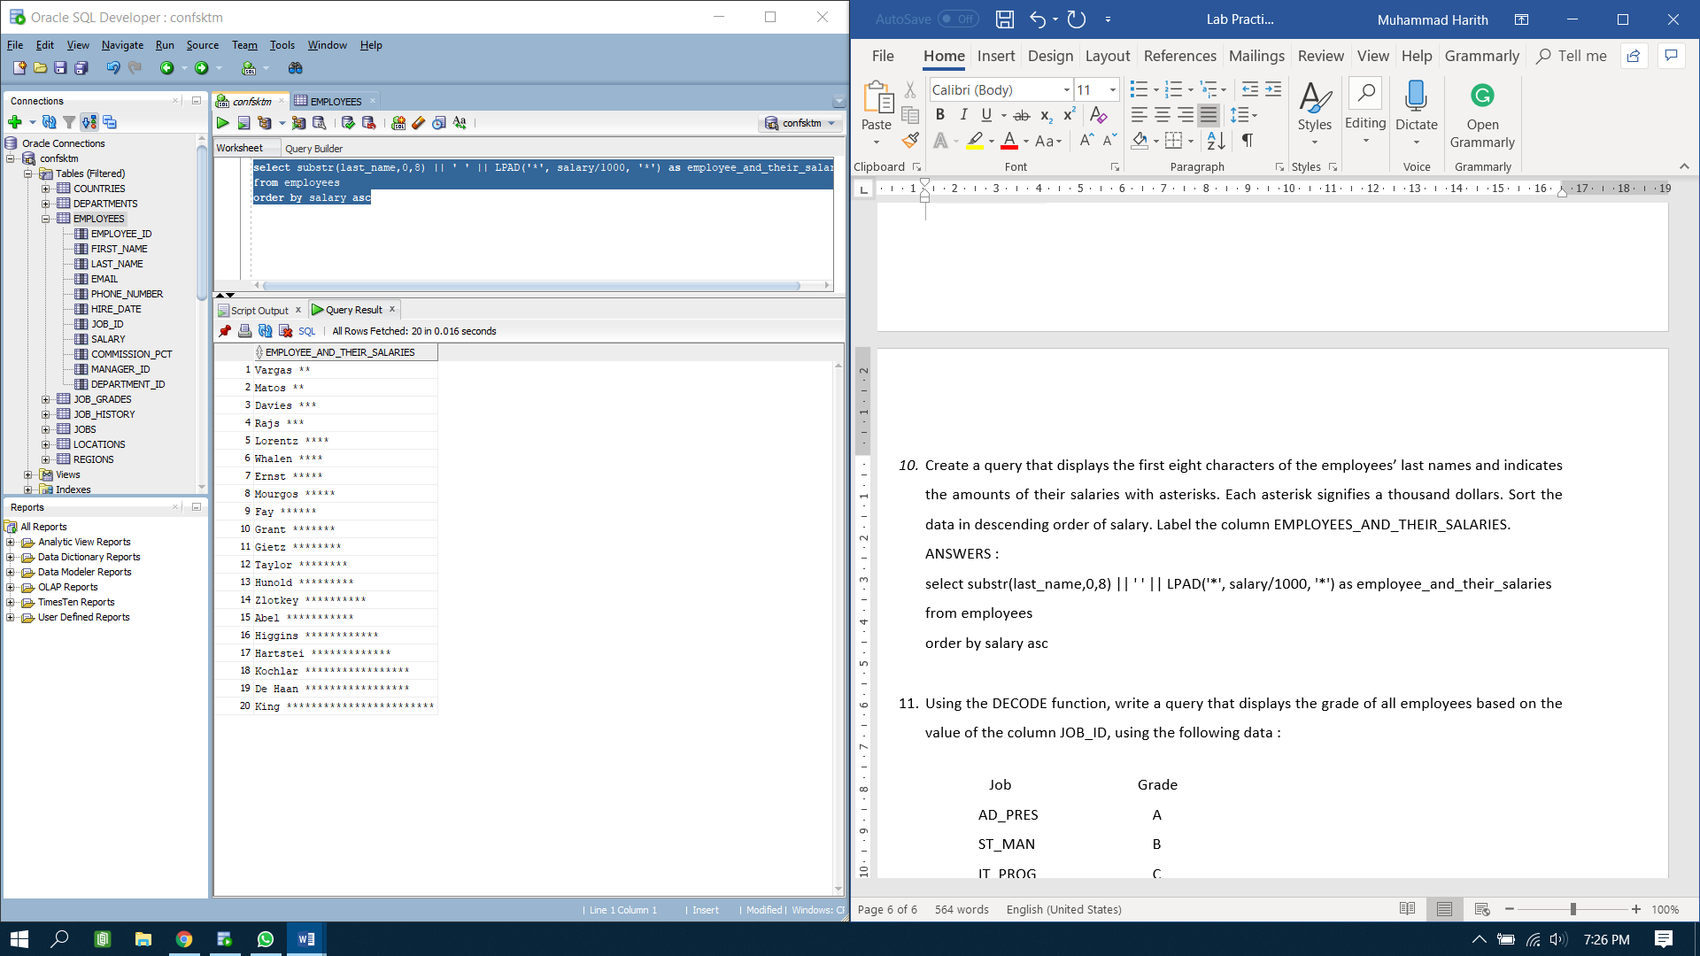

1. *Using the DECODE function, write a query that displays the grade of all employees based on the value of the column JOB_ID, using the following data :*

*Job Grade*

*AD_PRES A*

*ST_MAN B*

*IT_PROG C*

*SA_REP D*

*ST_CLERK E*

*None of the above 0*

**ANSWERS :**

select nvl(decode(job_id, 'AD_PRES','A', 'ST_MAN', 'B', 'IT_PROG', 'C', 'SA_REP', 'D', 'ST_CLERK', 'E', null, 0), 0)

result from employees

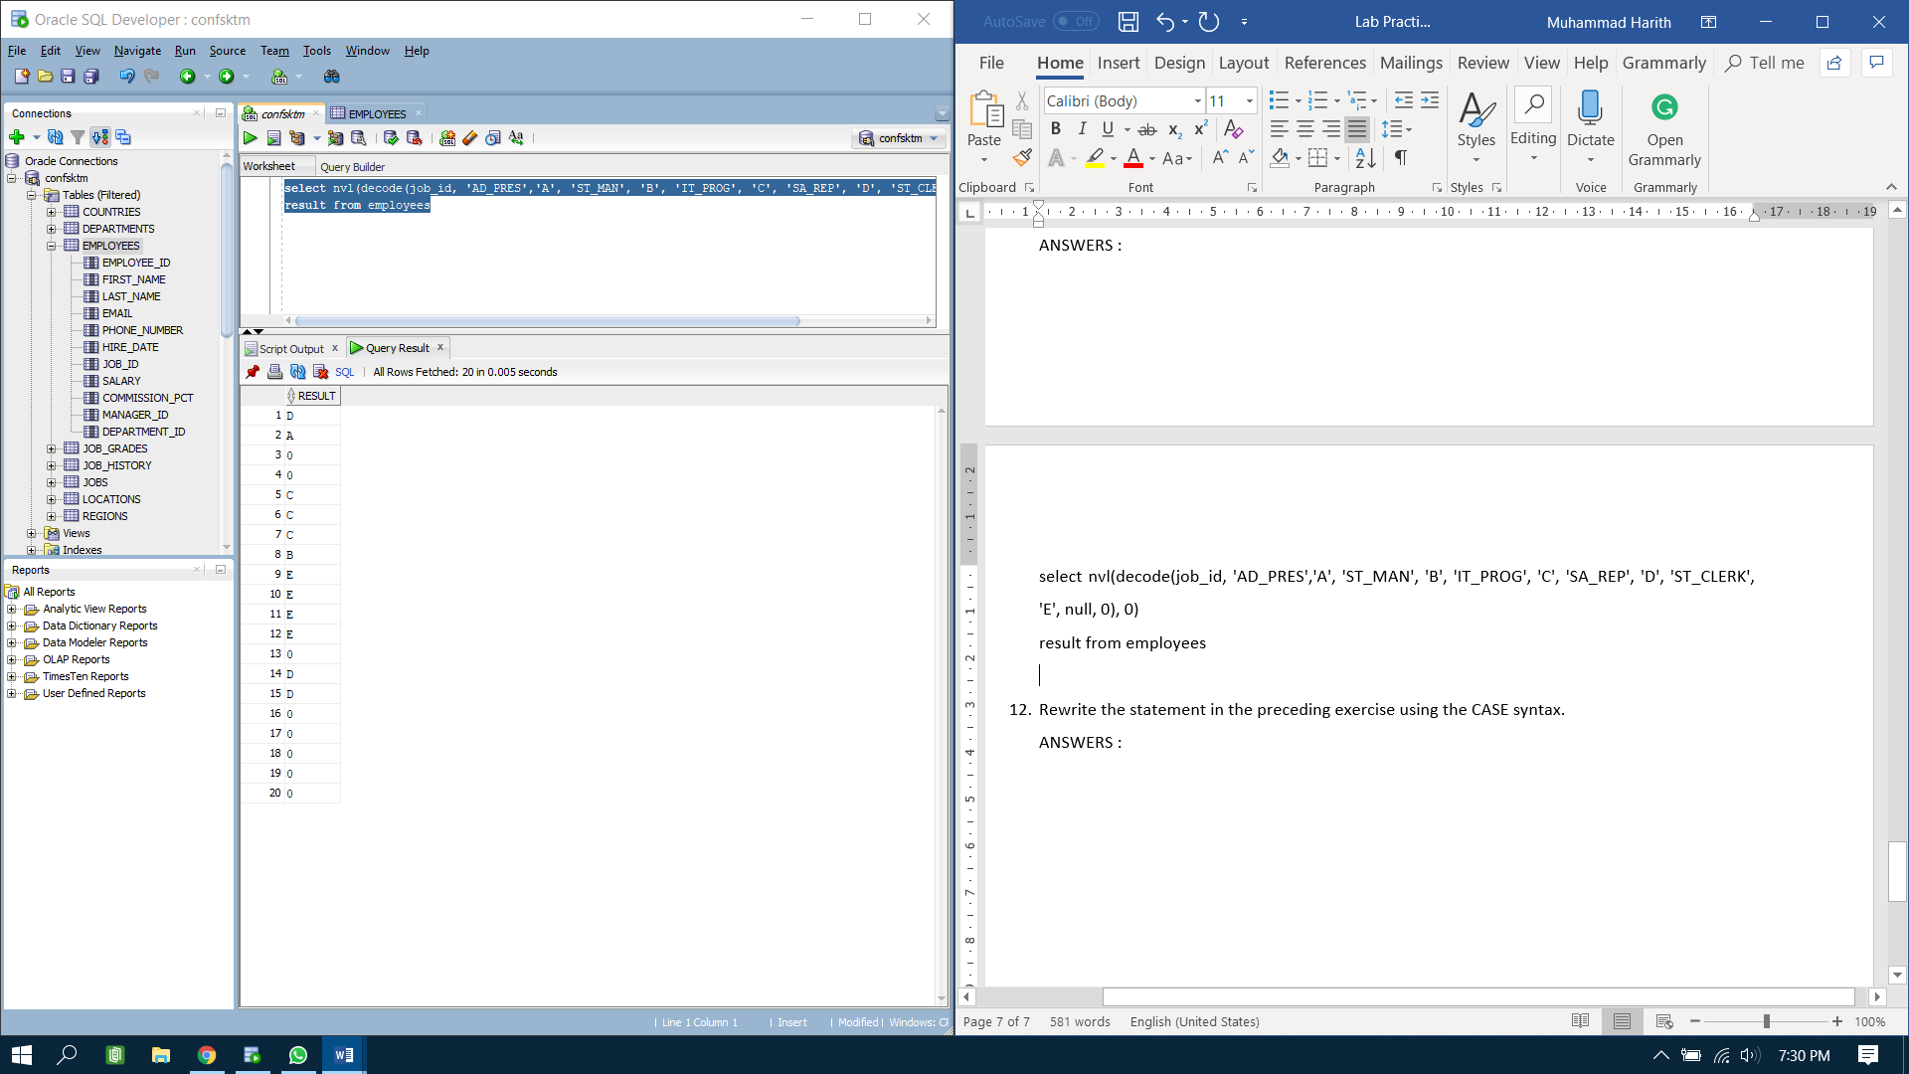

1. *Rewrite the statement in the preceding exercise using the CASE syntax.*

**ANSWERS :**

select job_id, case job_id

when 'ST_CLERK' then 'E'

when 'SA_REP' then 'D'

when 'IT_PROG' then 'C'

when 'ST_MAN' then 'B'

when 'AD_PRES' then 'A'

else '0' end grade

from employees

